Support Group for Families and Individuals with Disabilities

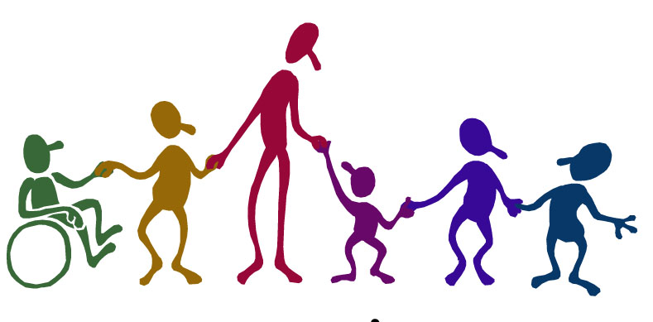
“We all have similar goals, only different ways of getting there.”

- When a family faces a diagnosis of a chronic health condition, a developmental, physical or behavioral challenge, it may produce a sense of loss, fear, anger isolation, and/or frustration.
- This multi-family group is designed to provide support and information to individuals and families with disabilities.
- This group will not focus specifically on any one disability, but will provide support and information of a broad nature.

Counseling and Mental Health Professions Clinic
131 Hofstra University
The Joan and Arnold Saltzman Community Services Center
Only $15 Per Session!

Hempstead, NY 11549

Call today to Register!

516-463-5234

